**PD Control**

**Topics Covered**

• Servo position control.

• Proportional-derivative (PD) compensator.

• Designing control according to specifications.

**Prerequisites**

• Integration laboratory experiment.

• Filtering laboratory experiment.

• Second-Order Systems laboratory experiment.

**1 Background**

**1.1 Servo Model**

The QUBE-Servo 2 voltage-to-position transfer function is

*P* (*s*) =

Θ*m* (*s*)

*Vm* (*s*)

*K*

=

*s*(*τ s* + 1)

*,* (1.1)

where *K* = 21*.*9 rad/(V *−* s) is the model steady-state gain, *τ* = 0*.*15 s is the model time constant, Θ*m* (*s*) = *L* [*θm* (*t*)] is the motor / disk position, and *Vm* (*s*) = *L* [*vm* (*t*)] is the applied motor voltage. If desired, you can conduct an experiment to find more precise model parameters, *K* and *τ* , for your particular servo (e.g. performing the Bump Test Modeling laboratory experiment).

**1.2 PID Control**

The proportional, integral, and derivative control can be expressed mathematically as follows

*t*

∫

*u*(*t*) = *kp e*(*t*) + *ki*

0

*e*(*τ* )*dτ* + *kd*

*de*(*t*)

*.* (1.2)

*dt*

The corresponding block diagram is given in Figure 1.1. The control action is a sum of three terms referred to as proportional (P), integral (I) and derivative (D) control gain. The controller Equation 1.2 can also be described by the transfer function

*C* (*s*) = *kp* +

*ki* + *k s.* (1.3)

*s d*

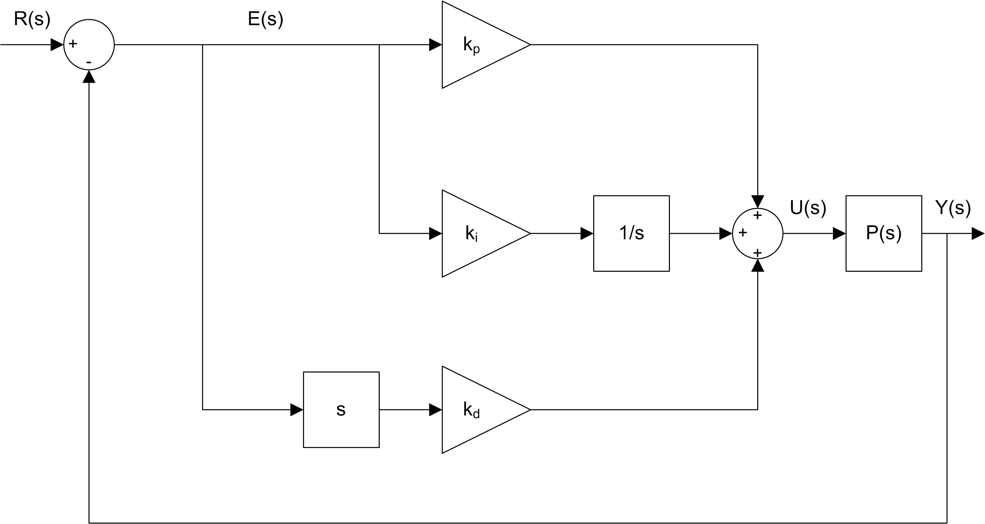

Figure 1.1: Block diagram of PID control

The functionality of the PID controller can be summarized as follows. The proportional term is based on the present error, the integral term depends on past errors, and the derivative term is a prediction of future errors.

The PID controller described by Equation 1.2 or Equation 1.3 is an ideal PID controller. However, attempts to implement such a controller may not lead to a good system response for real-world system. The main reason for this is that measured signals always include measurement noise. Therefore, differentiating a measured (noisy) signal will result in large fluctuations, thus will result in large fluctuations in the control signal.

**1.3 PV Position Control**

The integral term will not be used to control the servo position. A variation of the classic PD control will be used: the proportional-velocity control illustrated in Figure 1.2. Unlike the standard PD, only the negative velocity is fed back (i.e. not the velocity of the *error* ) and a low-pass filter will be used in-line with the derivative term to suppress measurement noise. The combination of a first order low-pass filter and the derivative term results in a high-pass filter *H* (*s*) which will be used instead of a direct derivative.

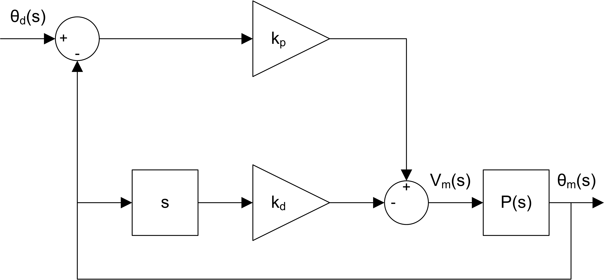

Figure 1.2: Block diagram of PV control

The proportional-velocity (PV) control has the following structure

*u* = *kp* (*r*(*t*) *− y*(*t*)) *− kd y*˙ (*t*)*,* (1.4)

where *kp* is the proportional gain, *kd* is the derivative (velocity) gain, *r* = *θd* (*t*) is the setpoint or reference motor /

load angle, *y* = *θm* (*t*) is the measured load shaft angle, and *u* = *Vm* (*t*) is the control input (applied motor voltage).

The closed-loop transfer function of the QUBE-Servo 2 is denoted *Y* (*s*)/*R*(*s*) = Θ*m* (*s*)/Θ*d* (*s*). Assume all initial conditions are zero, i.e. *θm* (0*−* ) = 0 and *θm*˙ (0*−* ) = 0, taking the Laplace transform of Equation 1.4 yields

*U* (*s*) = *kp* (*R*(*s*) *− Y* (*s*)) *− kd sY* (*s*)*,*

which can be substituted into Equation 1.1 to result in

*Y* (*s*) =

*K*

*s* (*τ s* + 1)

(*kp* (*R*(*s*) *− Y* (*s*)) *− kd sY* (*s*)) *.*

Solving for *Y* (*s*)/*R*(*s*), we obtain the closed-loop expression

*Y* (*s*)

*R*(*s*)

= *K kp*

*τ s*2 + (1 + *K kd* ) *s* + *K kp*

*.* (1.5)

This is a second-order transfer function. Recall the standard second-order transfer function

*Y* (*s*)

*R*(*s*)

2

*ω*

= *n .* (1.6)

*s*2 + 2*ζ ωn s* + *ω*2

*n*

**2 In-Lab Exercises**

Based on the VI developed in the Integration laboratory experiment, design the VI shown in Figure 2.1. This implements the PV controller outlined in 1.3 with a low-pass filter of 100/(*s* + 100) in-line with the derivative branch of the controller resulting in a high-pass filter of 100*s*/(*s* + 100). Set the Signal Generator block such that the servo command (reference angle) is a square wave with an amplitude of 0*.*5 rad and at a frequency of 0*.*4 Hz.

The VI also consists of a PV control loop using the QUBE-Servo 2 model transfer function that relates Voltage *Vm* (*s*) to Position Θ*m* (*s*) according to Equation 1.1. This uses the *K* and *τ* parameters provided in the Background section of this lab (or those you found previously through a modeling lab).

Using the saved response, the peak time and overshoot can be found as discussed in Second-Order Systems laboratory experiment. As shown in Figure 2.1, the PV response is ”saved” using the Collector block from the *Control & Simulation* | *Simulation* | *Utilities* palette and displayed in an XY Graph. LඉඊVIEW™ graphs (as opposed to charts) have cursors that can be used to take measurements.

1. Design and run the VI. The response should look similarly to Figure 2.2.

2. Set *kp* = 2*.*5 V/rad and *kd* = 0 V/(rad/s). Keep the derivative gain at 0 and vary *kp* between 1 and 4. What does the proportional gain do when controlling servo position?

3. Set *kp* = 2*.*5 V/rad and vary the derivative gain *kd* between 0 and 0*.*15 V/(rad/s). What is its effect on the position response?

4. Click on the Stop button to stop the VI.

5. Find the proportional and derivative gains required for the QUBE-Servo 2 closed-loop transfer function given in Equation 1.5 to match the standard second-order system in Equation 1.6. Your gain equations will be a function of *ωn* and *ζ* .

6. For the response to have a peak time of 0*.*15 s and a percentage overshoot of 2*.*5 %, the natural frequency and damping ratio needed are *ωn* = 32*.*3 rad/s and *ζ* = 0*.*76. Using the QUBE-Servo 2 model parameters *K* and *τ* given above in Section 1.1 (or those you found previously through a modeling lab), calculate the control gains needed to satisfy these requirements.

7. Run the PV controller with the newly designed gains on the QUBE-Servo 2. Attach the position response as well as the motor voltage used. For example, you can use the *Export* | *Export Simplified Image* functionality to save the measured load/disk speed and motor voltage to a picture file and attach that to your report.

8. Measure the percent overshoot and peak time of the response. Do they match the desired percent overshoot and peak time specifications given in Step 6 without saturating the motor (going beyond *±*10 V)?

**Hint:** Use the cursor palette in the XY Graph to measure points off the plot and the equations from laboratory experiment Second-Order Systems. off the plot and the equations from laboratory experiment Second-Order Systems.

9. If your response did not match the above overshoot and peak time specification, try tuning your control gains until your response does satisfy them. Attach the resulting response, measurements, and comment on how you modified your controller to arrive at those results.

10. Click on the Stop button to stop the VI.

11. Power *OFF* the QUBE-Servo 2.

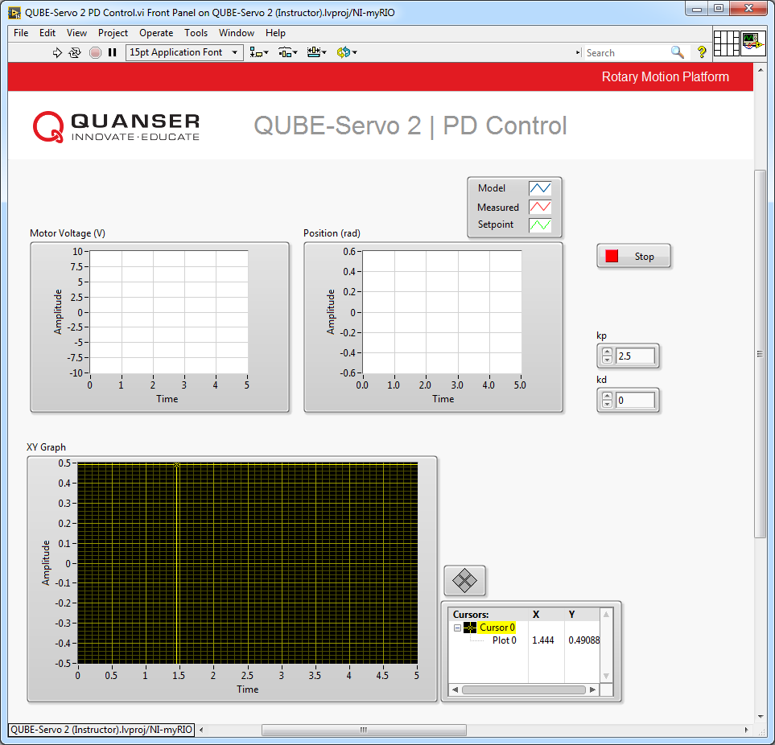

(a) Front Panel

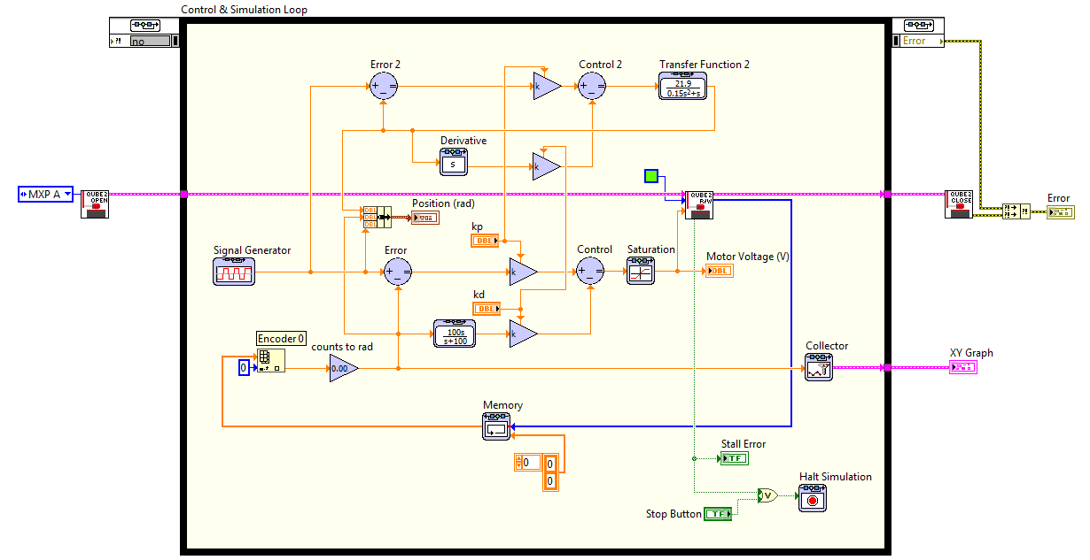

(b) Block Diagram

Figure 2.1: PV control on QUBE-Servo 2

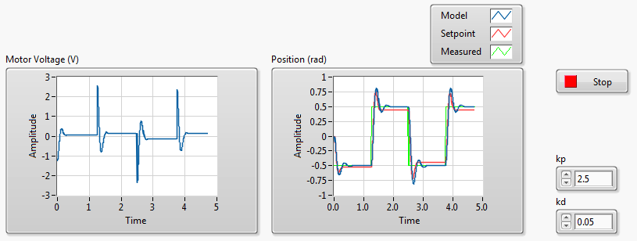

Figure 2.2: QUBE-Servo 2 PV control with *kp* = 2*.*5 V/rad and *kd* = 0*.*05 V/(rad/s).

© 2017 Quanser Inc., All rights reserved.

Quanser Inc.

119 Spy Court

Markham, Ontario

L3R 5H6

Canada

[info@quanser.com](mailto:info@quanser.com)

Phone: 1-905-940-3575

Fax: 1-905-940-3576

Printed in Markham, Ontario.

For more information on the solutions Quanser Inc. offers, please visit the web site at:

[http://www.quanser.com](http://www.quanser.com/)

This document and the software described in it are provided subject to a license agreement. Neither the software nor this document may be used or copied except as specified under the terms of that license agreement. Quanser Inc. grants the following rights: a) The right to reproduce the work, to incorporate the work into one or more collections, and to reproduce the work as incorporated in the collections, b) to create and reproduce adaptations provided reasonable steps are taken to clearly identify the changes that were made to the original work, c) to distribute and publically perform the work including as incorporated in collections, and d) to distribute and publicly perform adaptations. The above rights may be exercised in all media and formats whether now known or hereafter devised. These rights are granted subject to and limited by the following restrictions: a) You may not exercise any of the rights granted to You in above in any manner that is primarily intended for or directed toward commercial advantage or private monetary compensation, and b) You must keep intact all copyright notices for the Work and provide the name Quanser Inc. for attribution. These restrictions may not be waved without express prior written permission of Quanser Inc.